Project Planning Phase
Project Planning Template (Product Backlog, Sprint Planning, Stories, Story points)

Date | 29 September 2026
Team ID | SWTID-2026-5660
Project Name | Script-Controlled ACL – Restrict Record Access Based on Field Value
Maximum Marks | 5 Marks

Product Backlog, Sprint Schedule, and Estimation (4 Marks)
Use the below template to create product backlog and sprint schedule
Sprint | Functional Requirement (Epic) | User Story Number | User Story / Task | Story Points | Priority | Team Members
Sprint-1 | User Authentication | USN-1 | As an EEE branch user, I can log in to the ServiceNow instance with my user name and password. | 1 | High | Mahalakshmi K
Sprint-1 | Access Restriction | USN-2 | As an EEE branch user, I can view records whose Branch field is EEE in the list view. | 2 | High | Lathika R
Sprint-1 | Access Restriction | USN-3 | As an EEE branch user, I can open an EEE record to read its details. | 2 | Medium | Mahalakshmi K
Sprint-1 | User Authentication | USN-4 | As a non-EEE branch user, I can log in to the ServiceNow instance with my user name and password. | 1 | Medium | Manoj K
Sprint-1 | Access Restriction | USN-5 | As a non-EEE branch user, I am blocked from viewing records whose Branch field is EEE. | 3 | High | Lathika R, Manoj K
Sprint-2 | Access Restriction | USN-6 | As a non-EEE branch user, I see an access-denied message if I open an EEE record link directly. | 2 | Medium | Manoj K
Sprint-2 | Testing and Verification | USN-7 | As a tester, I can impersonate an EEE user and confirm that EEE records are visible. | 5 | Medium | Mahalakshmi K
Sprint-2 | Testing and Verification | USN-8 | As a tester, I can impersonate a non-EEE user and confirm that EEE records are hidden. | 5 | Medium | Manoj K
Sprint-1 | Branch Data Setup | USN-9 | As an administrator, I can add a Branch field to the table and set the Branch value on users and records. | 3 | High | Mahalakshmi M
Sprint-1 | Script-Controlled ACL | USN-10 | As an administrator, I can create a script-controlled ACL for the read operation on the table. | 3 | High | Lathika R
Sprint-1 | Script-Controlled ACL | USN-11 | As an administrator, I can write the ACL script to allow access only when the user is from the EEE branch or has the admin role. | 5 | High | Lathika R, Mahalakshmi M
Sprint-2 | Administrator Access | USN-12 | As an administrator, I can view all records irrespective of the Branch value. | 3 | High | Mahalakshmi M

Project Tracker, Velocity & Burndown Chart: (4 Marks)
Sprint | Total Story Points | Duration | Sprint Start Date | Sprint End Date (Planned) | Story Points Completed (as on Planned End Date) | Sprint Release Date (Actual)
Sprint-1 | 20 | 6 Days | 05 Oct 2026 | 10 Oct 2026
Sprint-2 | 15 | 6 Days | 12 Oct 2026 | 17 Oct 2026

Velocity:
Imagine we have a 10-day sprint duration, and the velocity of the team is 20 (points per sprint). Let’s calculate the team’s average velocity (AV) per iteration unit (story points per day)

Team 11 (planned): Sprint-1 velocity is 20 story points over a 6-day sprint, so AV = 20 / 6 ≈ 3.3 story points per day. Sprint-2 velocity is 15 story points over 6 days, so AV = 15 / 6 = 2.5 story points per day.

Burndown Chart:
A burn down chart is a graphical representation of work left to do versus time. It is often used in agile software development methodologies such as Scrum. However, burn down charts can be applied to any project containing measurable progress over time.
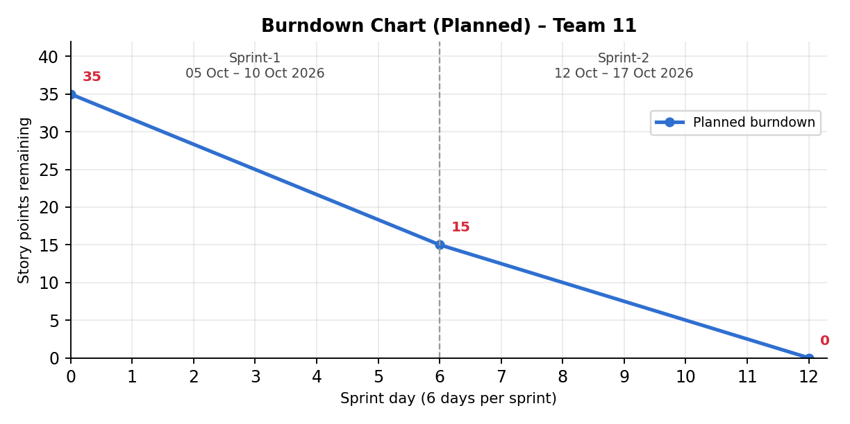
Planned burndown for Sprint-1 and Sprint-2 (35 story points in total); the actual line can be added as the sprints are completed.

https://www.visual-paradigm.com/scrum/scrum-burndown-chart/
https://www.atlassian.com/agile/tutorials/burndown-charts

Reference:
https://www.atlassian.com/agile/project-management
https://www.atlassian.com/agile/tutorials/how-to-do-scrum-with-jira-software
https://www.atlassian.com/agile/tutorials/epics
https://www.atlassian.com/agile/tutorials/sprints
https://www.atlassian.com/agile/project-management/estimation
https://www.atlassian.com/agile/tutorials/burndown-charts

